**Image Annotation Using SVM**

*Claudio Cusano, Gianluigi Ciocca, Raimondo Schettini*

This paper is based on automatic image annotation problems. According to this research problem they give some idea how we can annotate images automatically by using these methods. They divided **seven** classes for ordering pictures. The paper depicts a creative picture explanation instrument for ordering picture districts in one of **seven** classes - sky, skin, vegetation, day off, ground, and structures - or as obscure. This apparatus could be profitably applied in the executives of huge picture and video databases where an impressive volume of pictures and outlines there must be consequently listed. The explanation is performed by a grouping framework dependent on a **multi-class Support Vector Machine**. Exploratory outcomes on a test set of two hundred pictures are accounted for and examined. Automatic image annotation is useful for image recognition systems, smart scanners, digital cameras, photocopiers, and printers. This paper proposes a method capable of automatically annotating digital images by assigning regions to seven specific classes: **sky, skin, vegetation, snow, water, ground, and buildings**. The annotation is done by a classification method based on a multi-class Vector Support Computer.



**SUPPORT VECTOR MACHINES**

Support Vectors Machines were selected because they did not need any distributional assumptions about the features and offered strong generalization efficiency in other    imaging applications, including in the case of largescale object spaces. They introduced about SVM which is very important. The SVM methodology comes from the application of statistical learning theory to separating hyperplanes for binary classification problems. The **SVM** approach is focused on the implementation of mathematical learning theory to differentiate hyperplanes from binary classification problems. The central idea of **SVM** is to adjust the discriminating function so as to make optimal use of the separable information of boundary cases.  While SVMs are specifically built to differentiate between two classes, they can be tailored to multi-class problems.

**Multi-class SVM**

A multiclass SVM classifier can be obtained by training a number of classifiers and combining their results. There are many techniques to merge SVMs, popular approaches are "one per class" and "pairwise coupling." They used various **SVM** based classification techniques and feature sets to semantically identify regions in digital images.  Seven levels were taken into account. For classification, a multi-class SVM was used by them, built according to the "one per class" technique. In order to train each of the seven SVMs, 1500 tiles of   the relevant class, taken from the training package, and a random collection of 1500 tiles of the other classes were used. Through **SVM** was thus qualified to differentiate between one class and the other. In the testing phase, they computed a description of it in terms of low-level features. They used histograms as feature vectors, because they are very simple to compute and have given good results in practical applications, where feature extraction must be as simple and rapid as possible. They initially used a simple histogram based on the quantization of the **HSV** color space in eleven bins. Because of their properties of effectiveness and invariance properties in turn and interpretation, shading histograms are generally utilized for content-based picture ordering and recovery. Be that as it may, a shading histogram just records shading dispersion; other conceivably helpful properties of the pictures are lost.

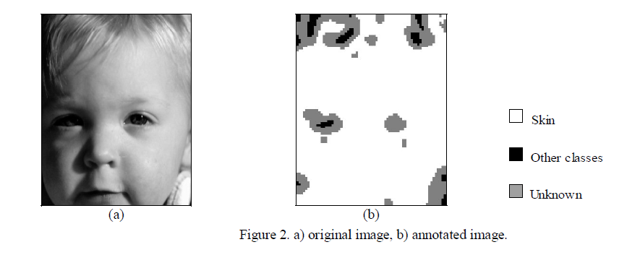

They have utilized what is known as a joint histogram. This is a multidimensional histogram which can join extra data about shading circulation, edge and surface measurements and any sort of neighborhood pixel highlight without yielding the heartiness of shading histograms. Each section in a joint histogram contains the division of pixels in the picture that are depicted by a specific blend of highlight esteems. The joint histogram utilized here consolidates shading appropriation with angle measurements. Shading dispersion is portrayed by the quantization of the **HSV** shading space. The level and vertical segments of the angle are registered by the use of Sobel's channels to the luminance picture. For every part, the supreme worth is taken and afterward quantized in four canisters based on examination with three limits. The edges have been chosen taking the 0.25, 0.50, also, 0.75 quantiles of the circulation of the supreme estimation of slope segments, assessed by an arbitrary determination of more than 2,000,000 pixels in the pictures of the preparation set.

After the good preparing of a classifier, they structured a methodology for explaining entire pictures. So as to name each pixel of the picture as having a place with one of the classes, we required an approach to choose the tiles and afterward join different characterization results. In their **methodology**, the tiles are inspected at fixed interims. Since a few tiles cover, each pixel of the picture is found in a given number of tiles. Each tile is freely ordered, and the pixel's last name is chosen by larger part vote. Often a territory of the picture can't be marked with one of the seven classes chose, and for this situation various classes are frequently allotted to covering tiles. To address this sort of blunder and to accomplish all in all, a progressively dependable comment technique, they presented a dismissal alternative: when the portion of concordant votes identified with covering tiles lies underneath a certain limit, the pixels inside these tiles are named as having a place with an obscure class.



Practically speaking, the dismissal choice chooses the pixels that can't be appointed to any class with adequate certainty. While the precision of the method is very acceptable, they intend to further improve the technique as a whole. Classified pixels are generally on the boundary between two classes, or within very dark areas, where color and texture information is not sufficient. The categories of mistake produced by the device   indicate that it cannot be used as a segmentation method: a more precise segmentation technique will be required for this reason. In this paper we came to know about **SVM** and **multi-SVM** and some methods about automatically image annotation. They used some downloaded images from web. we can use more good quality images for better results. They divided seven classes but there should more classes to identify image more accurately. Their methodology was structured for explaining entire pictures.

**References:**

* Márquez, G.R. & Escalante, Hugo Jair & Sucar, Luis. (2011). Simplified quadtree image segmentation for image annotation. CEUR Workshop Proceedings. 719. 24-34.
* Cusano, Claudio & Ab, Gianluigi & Ciocca, Gianluigi & Schettini, Raimondo. (2003). Image annotation using SVM. Internet Imaging V. 5304. 10.1117/12.526746.
* C. Faloutsos, R. Barber, M. Flickner, J. Hafner, W. Niblack, D. Petkovic, and W. Equitz, “Efficient and effective querying by image content”, Journal of Intelligent Information Systems, 3, pp. 231-262, 1994.
* K. R. Muller, S. Mika, G. Ratsch, K. Tsuda, and B. Scholkopf, "An introduction to kernel-based learning algorithms", IEEE Transactions on Neural Networks, 12(2), pp. 181-201, 2001.
* R. Lienhart and A. Hartmann, "Classifying images on the web automatically", Journal of electronic imaging, 11(4), pp. 445-454, 2002.